IAM (IDENTITY ACESS MANAGER)
- CREATE ONE IAM USER AND ASSIGN EC2 AND S3 FULL ACCESS ROLES.
- Log in to your aws ccount
- Go to the IAM
- Create user
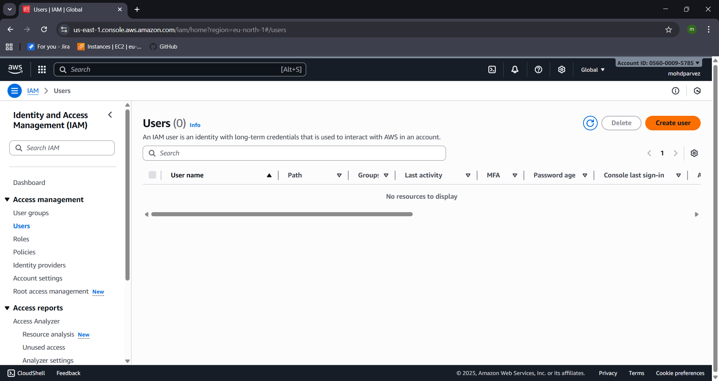
- Give the user name and click next
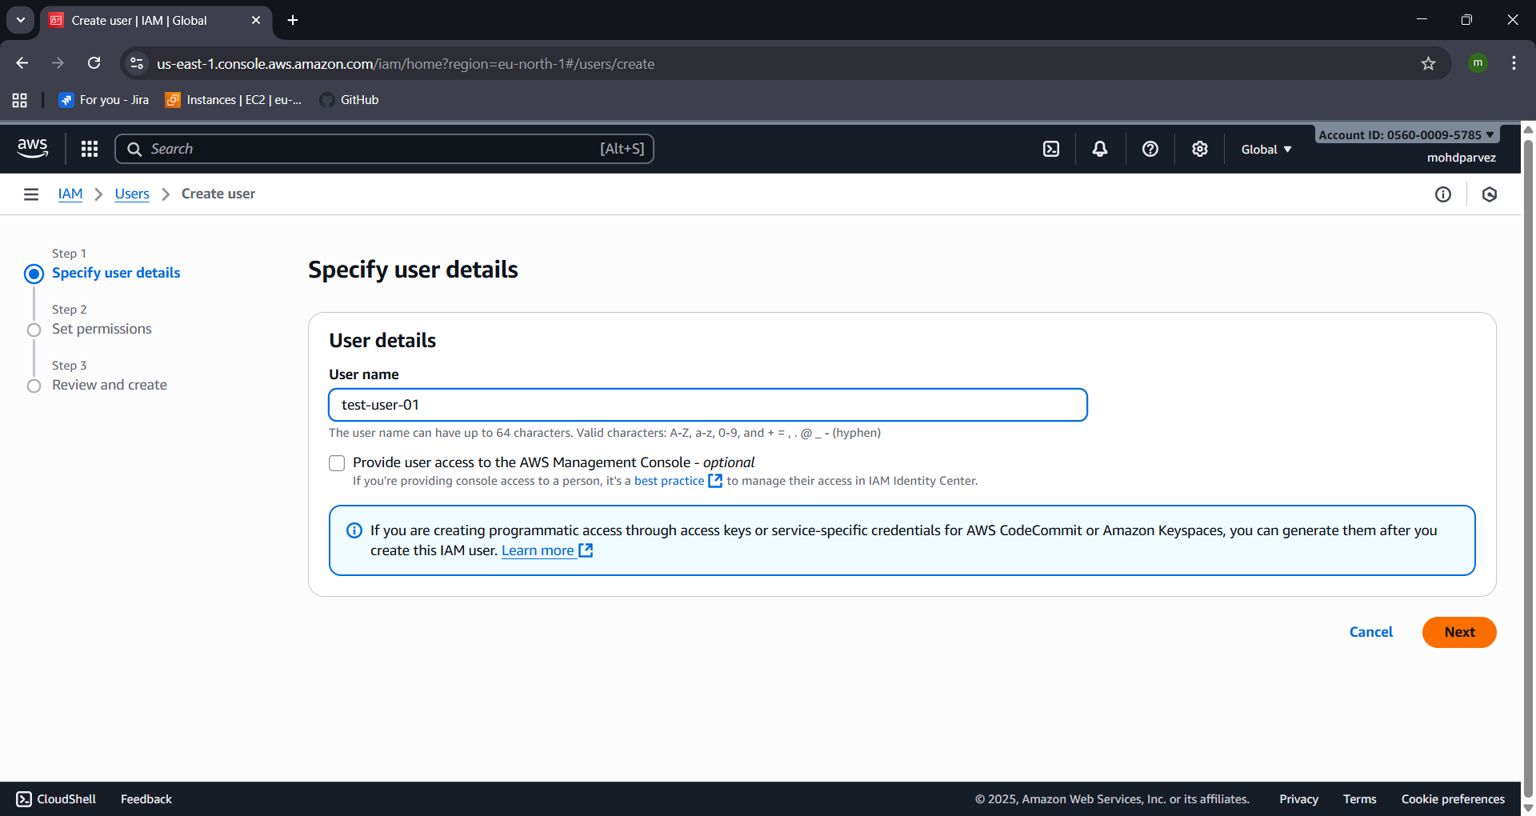
- Set permissions there are three options available
  - Add user to group : Add user to an existing group, or create a new group ehich has permissions already assigned to it so the new user can use it by adding user in group.
  - Copy permissions : to copy permissions or inline policy that has been already attached to existing user
  - Attach policies directly : to create policies and attach to the user.
- Select the attach policies : in you have customer managed policies and aws managed policies
- Customer managed : create the policy and use for the user
- Aws managed : the policies that are already created by aws it self to give permissions and acess.
- For now select the policy by searching for ec2
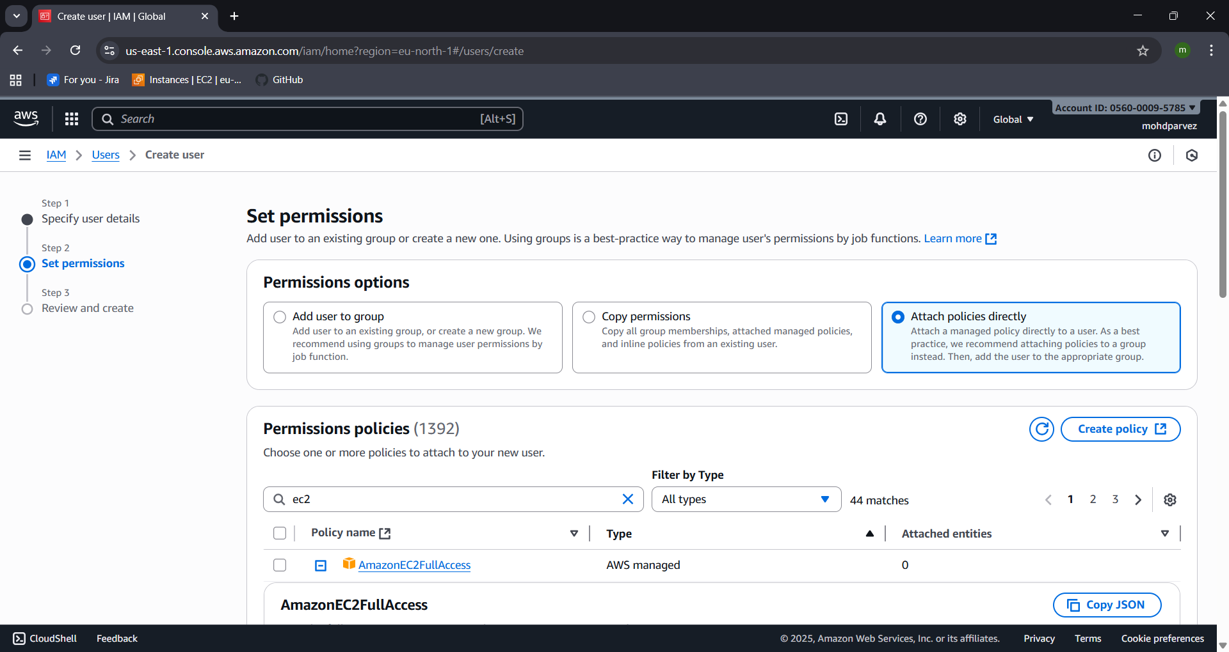
- Select amazonec2 full acess
- And also search for s3 and select fullacess to s3
- 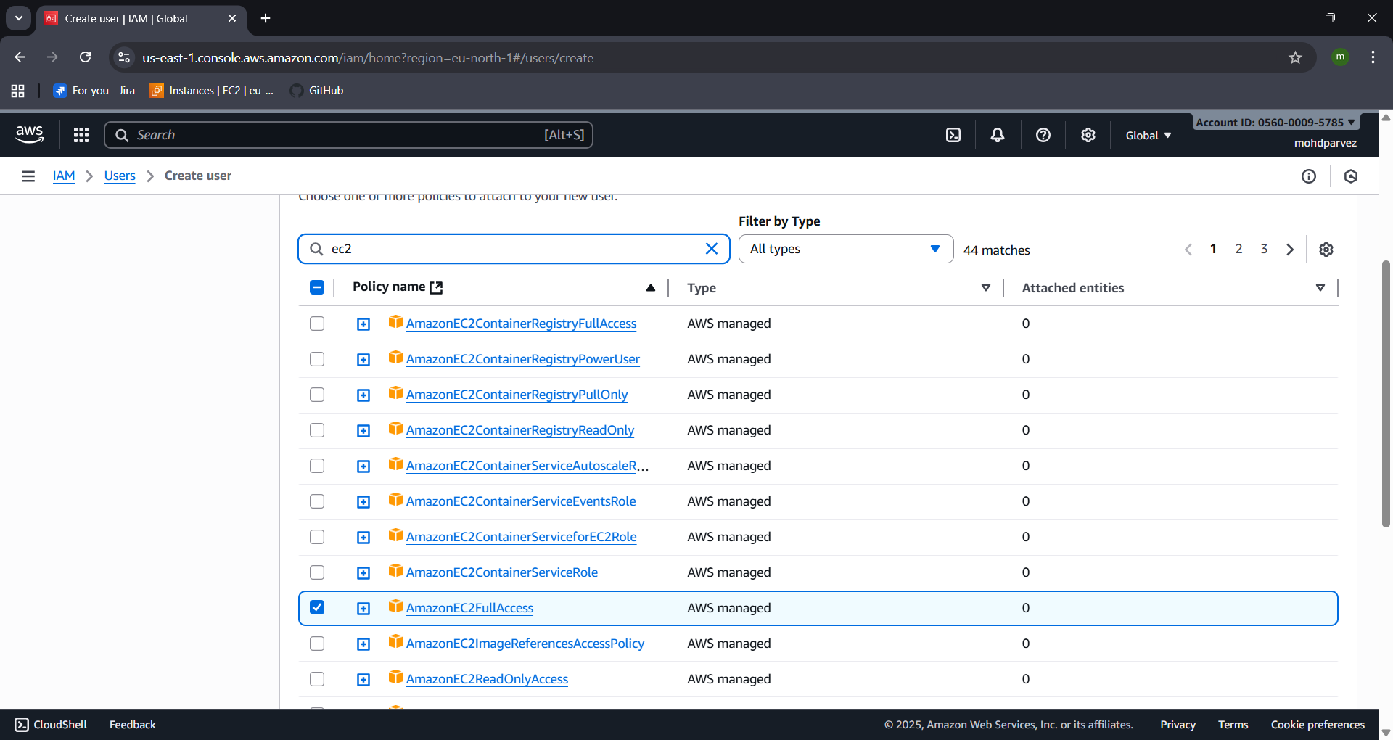
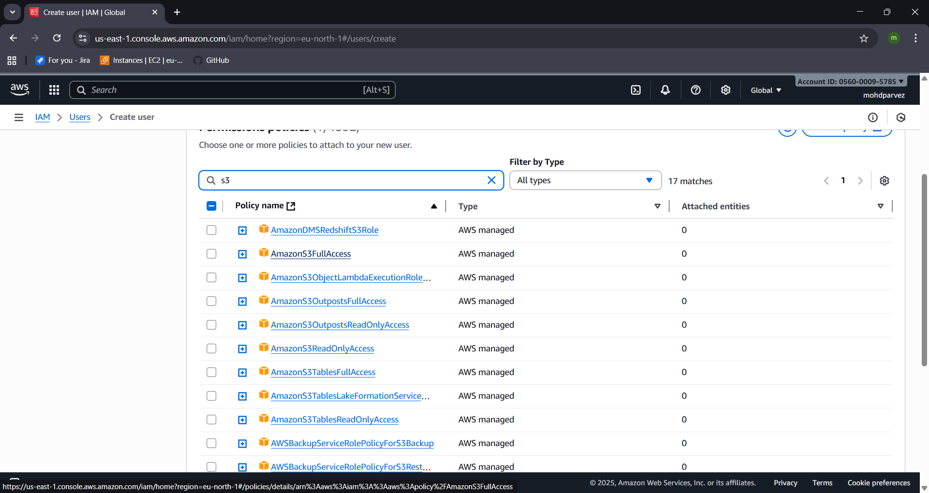
- Finally review and create the user with the permission
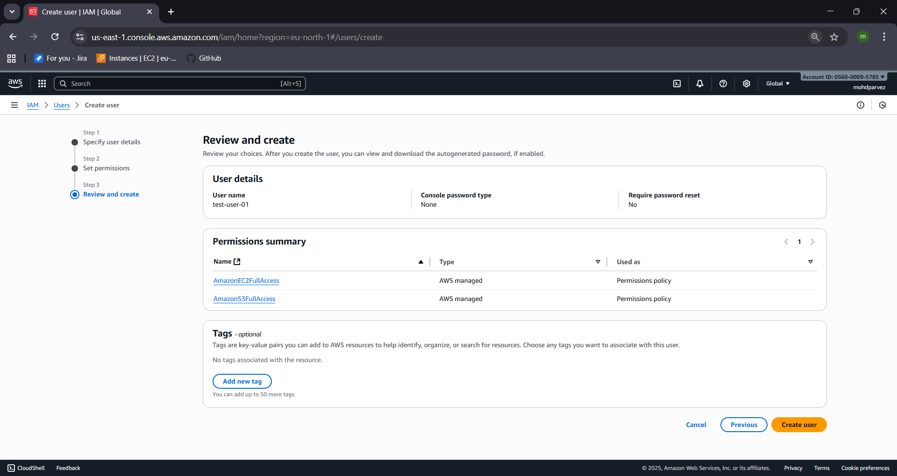
- The user will be created with the ec2 full acess and s3 full acess.
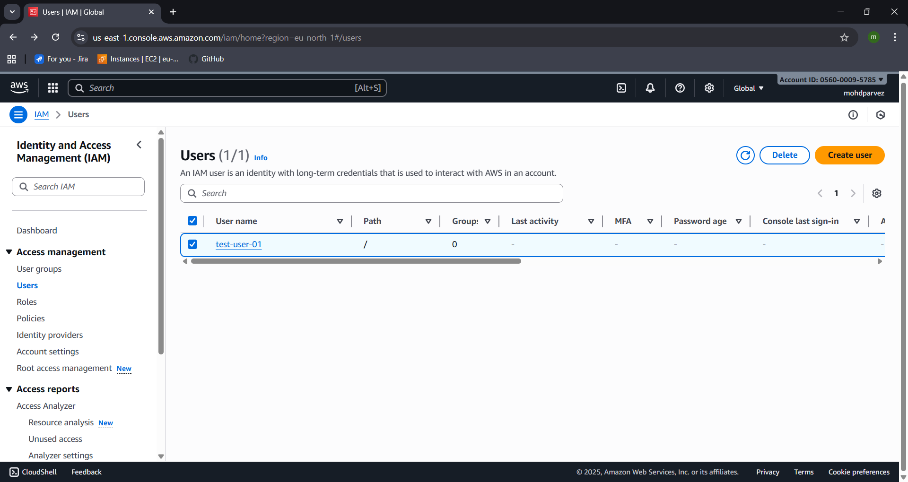

- CREATE ONE GROUP IN IAM AND ASSIGN READ ACCESS FOR EC2.
  - Go to IAM user groups
  - Create group – provide user group name
  - Then create user – ad policy of ec2 read only acess and create the user group
  - The user group with the read only access for ec2 has been created
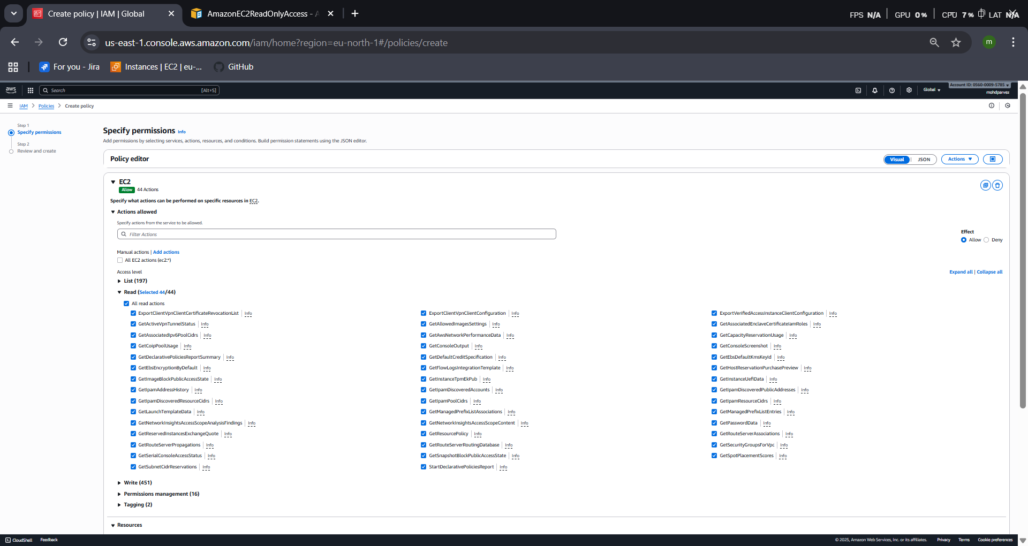
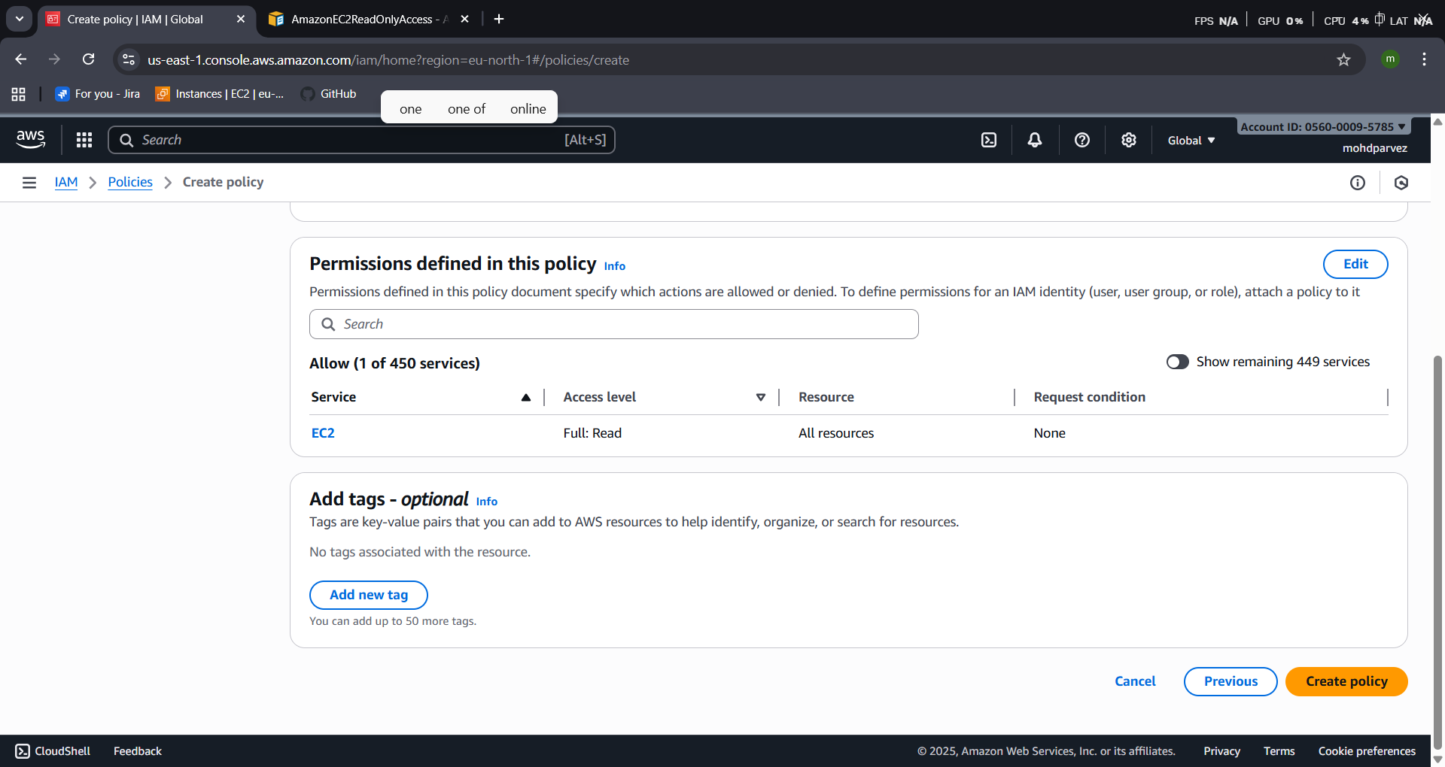
- After creating the policy
- Go to the user groups create user group –add the ec2 read only policy to the user group
- Now the user group is created with the read only policy of ec2
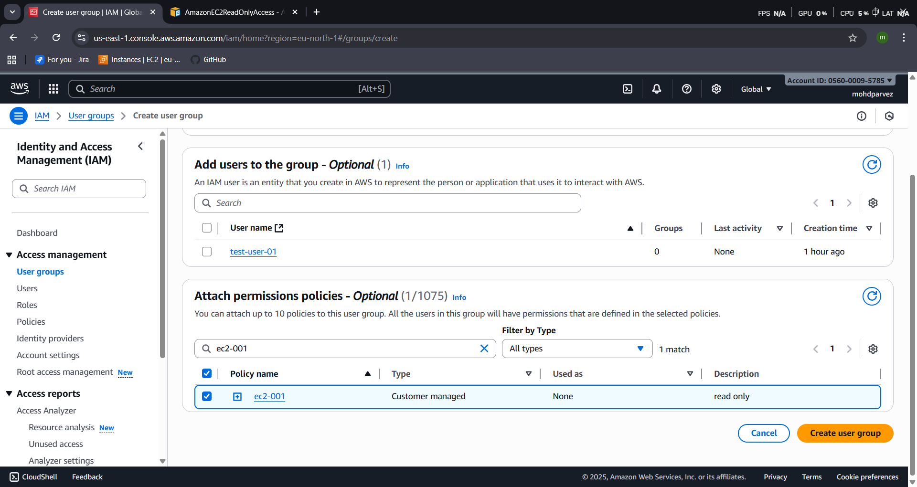
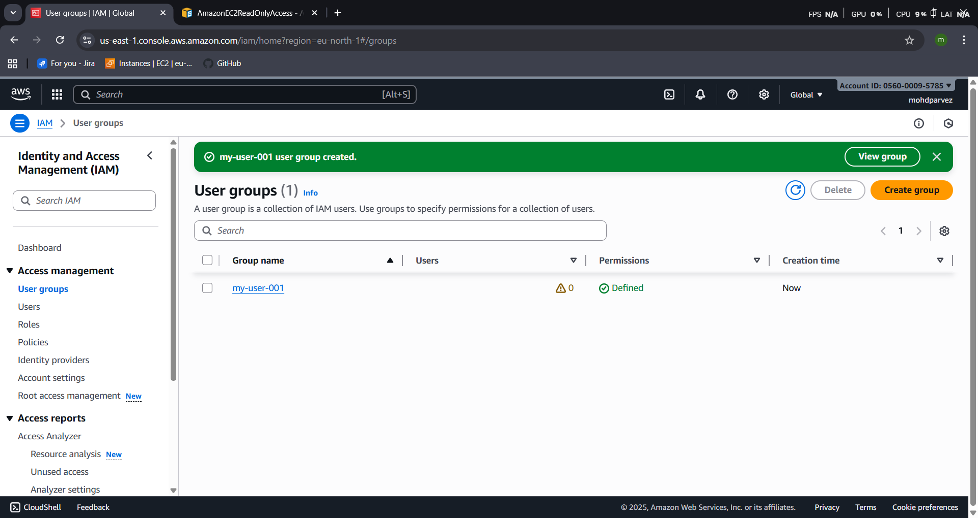
- CREATE A NEW USER NAMED "DEVOPS" AND ADD TO THE GROUP CREATED IN TASK 2.
  - Create the user with the user name devops donot attach or create the policy then add the user in the user group—select created so that it can aceesthhe [permissions created in the group automatically.
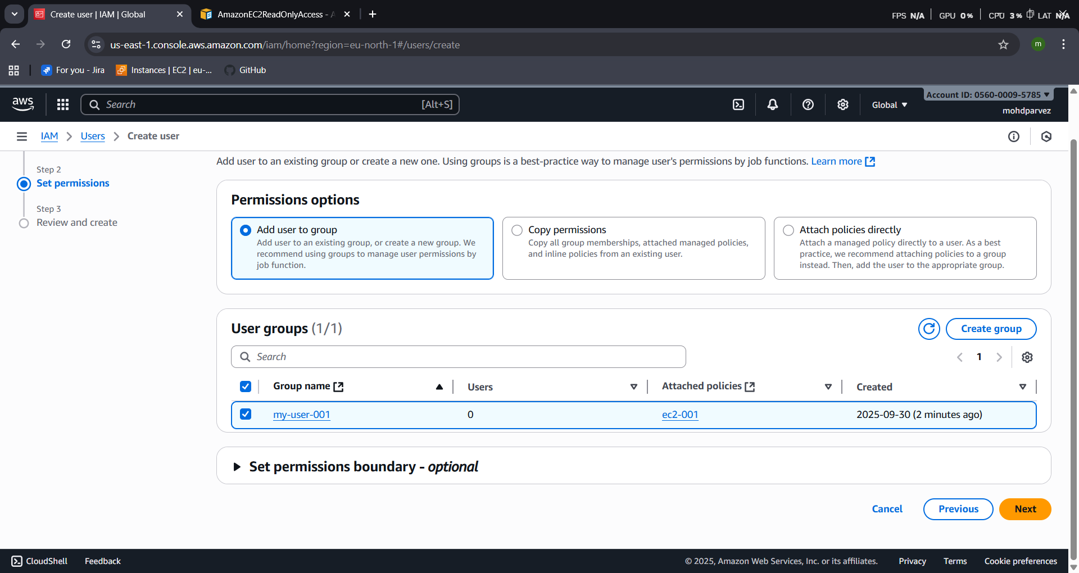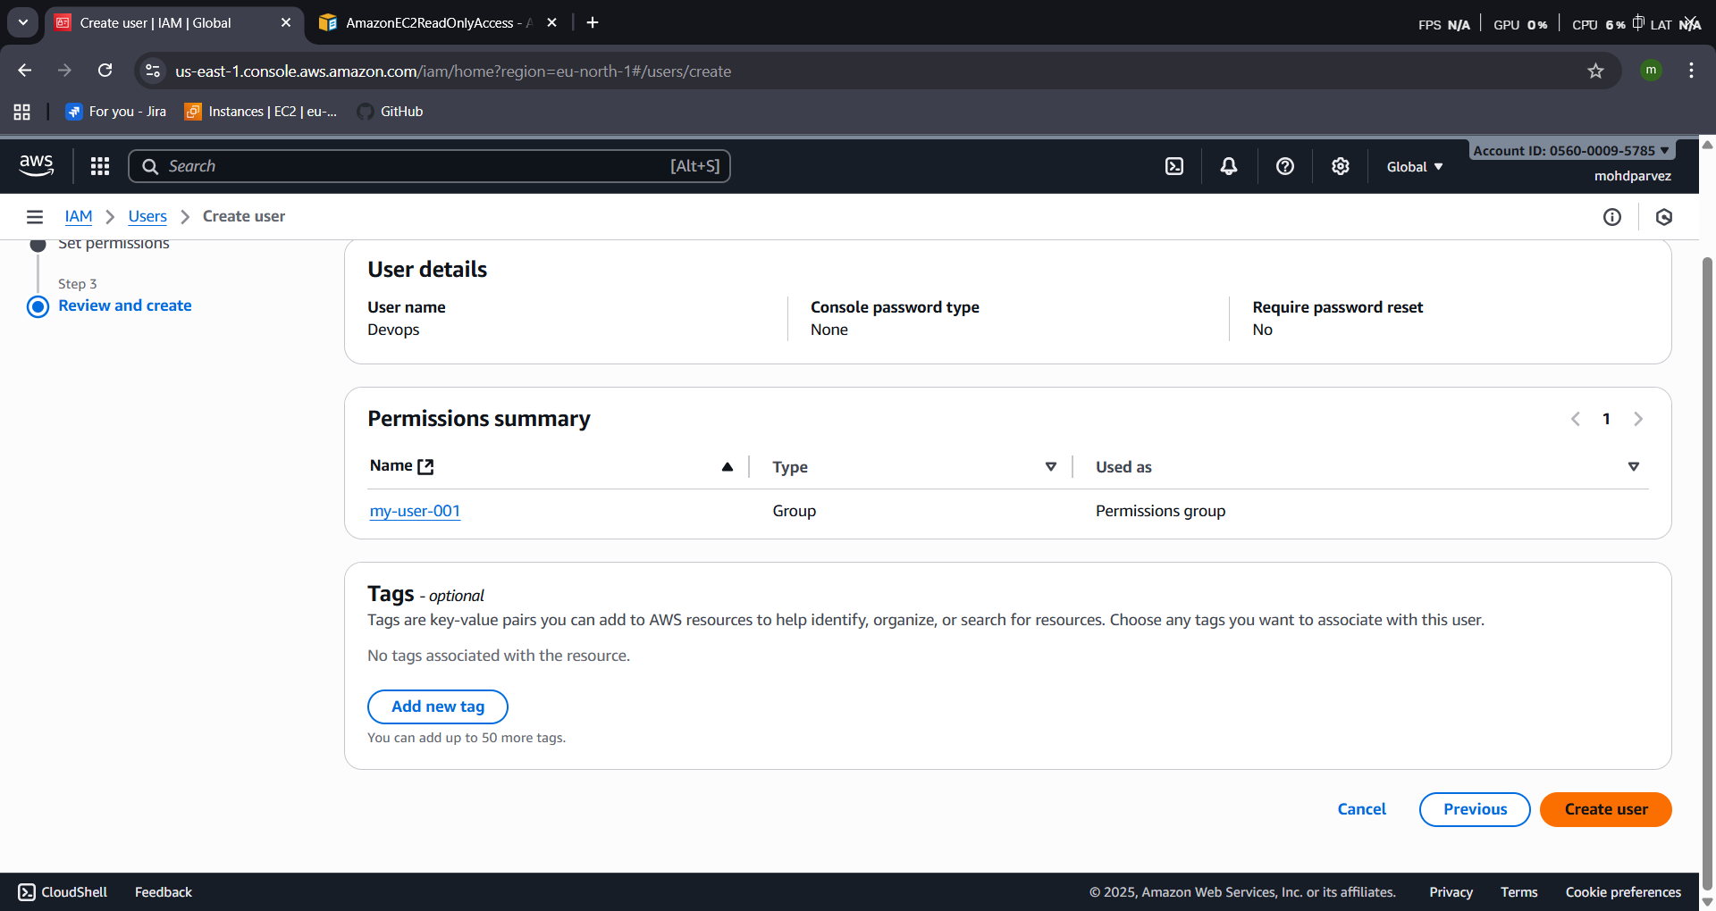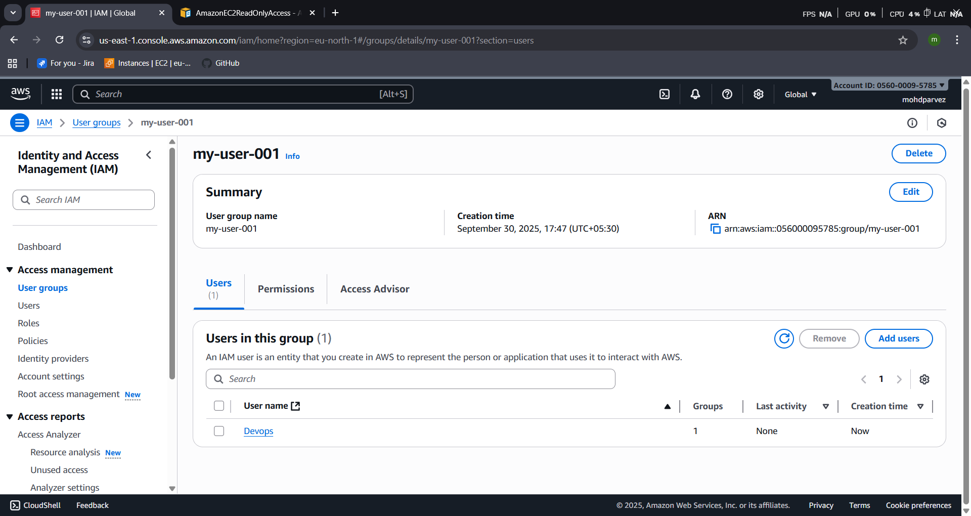

- WRITE A BASH SCRIPT TO CREATE AN IAM USER WITH VPC FULL ACCESS.
  - Connect to ec2 instance
  - Aws configure
  - Provide acess key and secret key , ouput format ,region

#!/bin/bash

aws iam create-user --user-name "$1"
aws iam attach-user-policy --user-name "$1" \
--policy-arn arn:aws:iam::aws:policy/AmazonVPCFullAccess
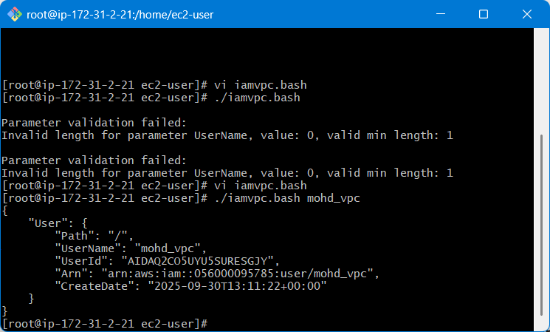

- CREATE AN IAM POLICY TO ALLOW EC2 ACCESS FOR A SPECIFIC USER IN SPECIFIC REGIONS ONLY.
- Create user
- Select iam
- Custom password create password
- Next click
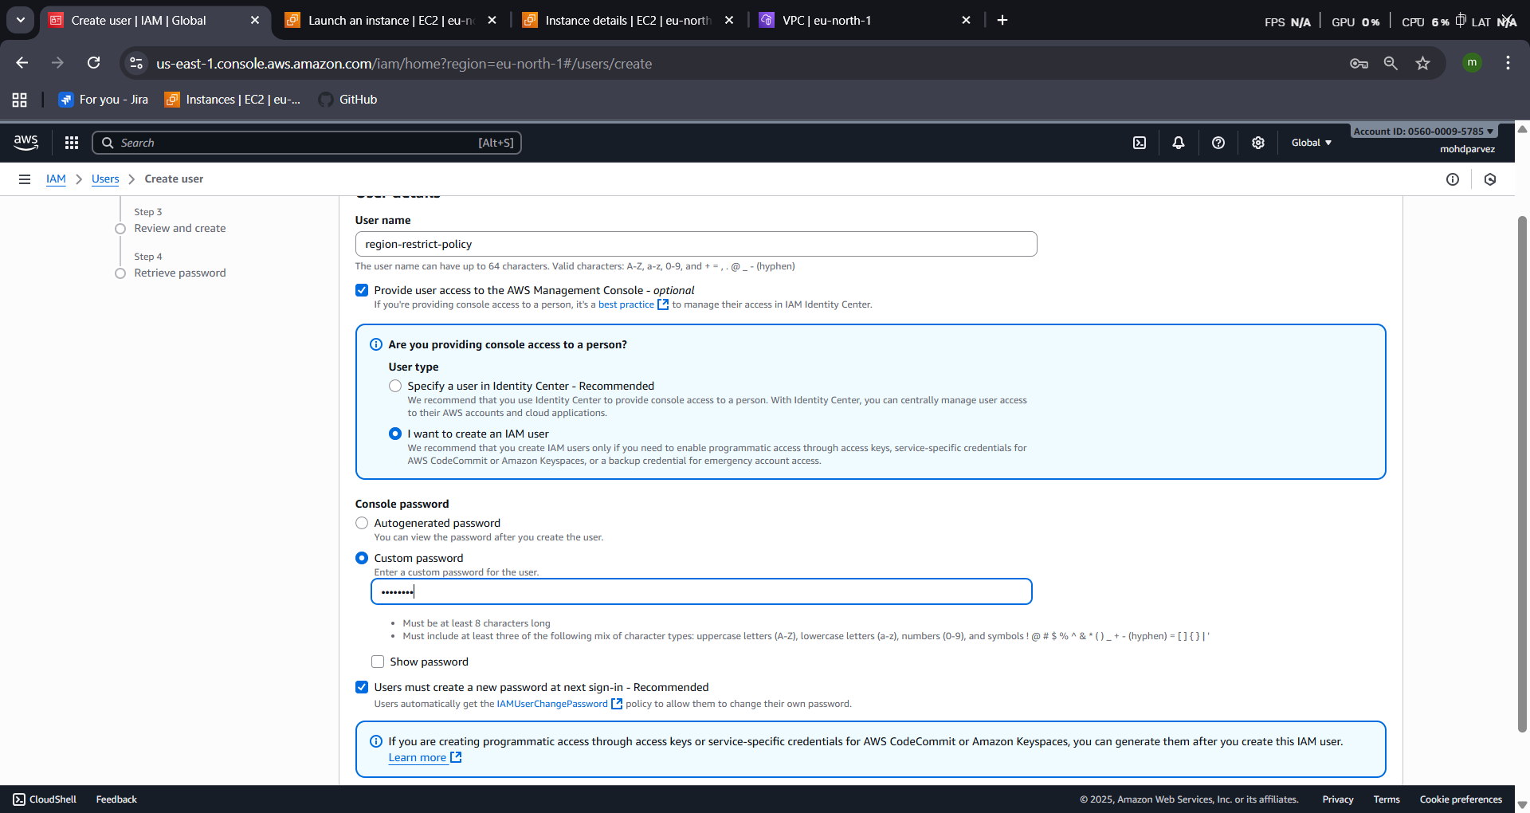

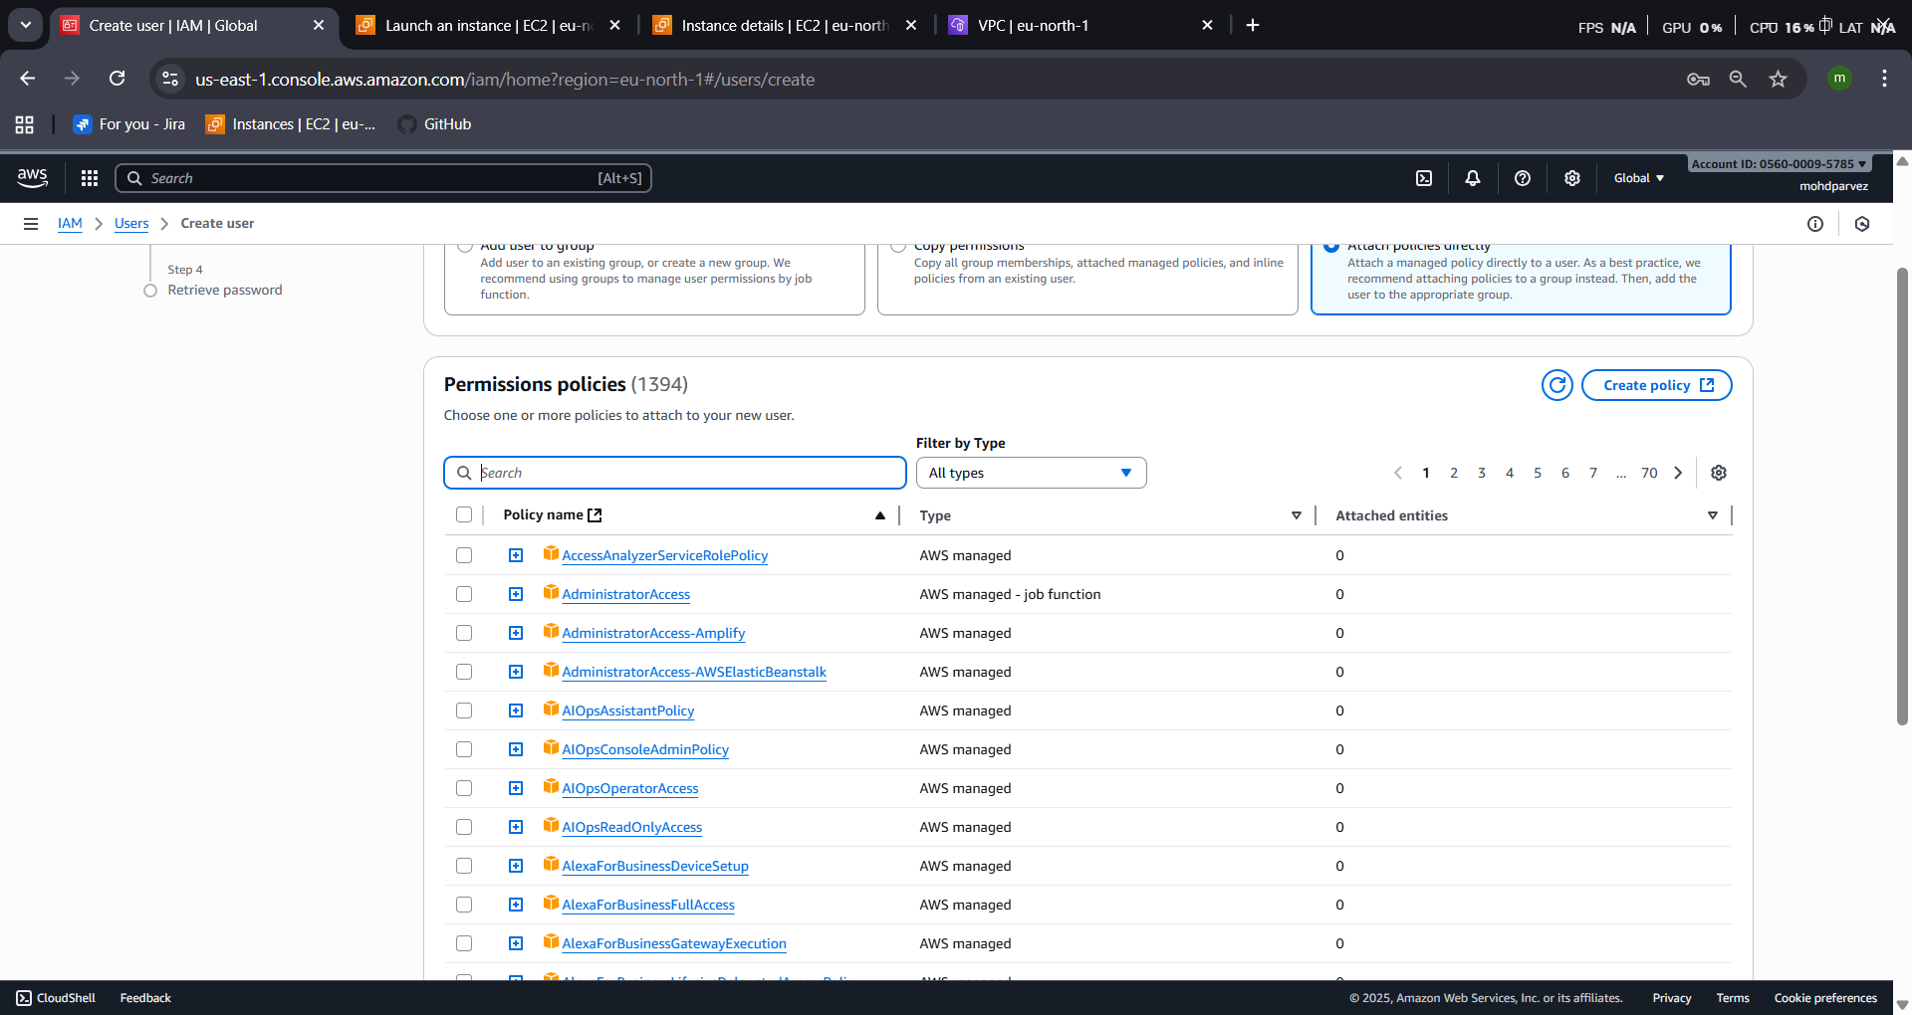
- Then provide the ec2 full acess policy to the user then create the user
- WE HAVE TWO ACCOUNTS: ACCOUNT A AND ACCOUNT B. ACCOUNT A USER SHOULD ACCESS AN S3 BUCKET IN ACCOUNT B.
- For this you need to create the cross peering to account
- Then configure aws cli in CLI
- Then you can access the s3 bucket from one account to another account
(Collaborate with a team member and execute this. This is mostly asked in every interview.)

